UCS Bolton
Strategic Careers Plan
2021 – 2022
&
2022 - 2023

Approved by: Date:
Last reviewed: October 2021+

Next review due by:

Contents

Vision……………………………………………………………………………………………………………….
Strategic Objectives………………………………………………………………………………………….
Intent………………………………………………………………………………………………………………
Implementation…………….………………………………………………………………………………..
Impact……………………………..………………………………………………………………………………

Appendices

Appendix 1 – SWOT Analysis……………………………………………………………………………….
Appendix 2 – Current State………………………………………………………………………………….
Appendix 3 – Gatsby Benchmark Progress……………………………………………………………
Appendix 4 – Year Group Careers Objectives and Outcomes…………………………………
Appendix 5 – Careers Programme…………………………………………………………………………
Appendix 6 – Detailed Action Plan………………………………………………………………………..
Appendix 7 – External Engagement Plan……………………………………………………………….
Appendix 8 – Monitoring and Evaluation Plan……………………………………………………….
Appendix 9 – Parental Engagement Plan……………………………………………………………….
Appendix 10 – Roles and Responsibilities………………………………………………………………
Appendix 11 – Digital Platform Strategic Rollout Plan………………………………………………

INTENT

Vision

To develop a whole school experience that allows students to be prepared with subject specific knowledge and pedagogy that secures the best Life Skills so that students are able to access the career and higher education destination of their choice.

Strategic Objectives

Objective 1 – To have careers and Life Skills interwoven throughout the T&L framework.

Objective 2 – Within the context of careers, develop coaching and target setting to motivate and contextualise learning and progression in lessons

Objective 3 – Develop the work with outside support agencies and employers to enrich the careers offer at the UCS.

Objective 4 – Develop the employer engagement through subject specific curriculum links and enrichment activities

Objective 5 – Develop the progression of careers knowledge over KS3 and KS4 preparing for post 16 success

Career Road Map

‘QUEST-UP’

 | Q | U | E | S | T
AIM | QUESTIONING  (Year 7)  Questioning what skills I might need for future careers, and identifying, through coaching, strengths and areas to develop in personal academic skills. | UNDERSTANDING  (Year 8)  Understanding the different career options and different demands of the local labour market and identifying, through coaching, strengths and areas to develop in personal academic skills. | EMPOWERING  (Year 9)  Empowering students to blend their career skills with specific challenges of the working world through the theme of ENTERPRISE, and identifying, through coaching, strengths and areas to develop in personal academic skills. | SECURING  (Year 10)  Securing work placements and developing the skills needed to be successful in chosen employment areas and identifying, through coaching, strengths and areas to develop in personal academic skills. | TAKE CONTROL  (Year 11)  Taking control of your post 16 destinations and ensuring guidance is correct, pathways understood and applications are successful, and identifying, through coaching, strengths and areas to develop in personal academic skills.

 | U | P
AIM | UTILISING  (Year 12)  Utilising and capturing the skills developed in school and link research, employability skills and academic progress to future destinations, matching those skills to lessons and personal development plans. | PROGRESSION  (Year 13)  Progression skills embedded to ensure destinations to UCAS, apprenticeships or the working world are secured, and matching those skills to lessons and personal development plans

Destination Data Year 11

Destination | 2017 | 2018 | 2019 | 2020
Education |  |  |  | 95%
Employment |  |  |  | 0%
NEET |  |  |  | 0%
Training |  |  |  | 2.5%
Unknown |  |  |  | 2.5%

Destination Data Year 13

Destination | 2017 | 2018 | 2019 | 2020
Education | 90% | 88% (16% Y14) | 94% (6% Y14) | 84% (4% Y14)
Employment | 5% | 0% | 3% | 8%
NEET | 0% | 0% | 0% | 0%
Training | 5% | 12% | 3% | 8%
Unknown | 0% | 0% | 0% | 0%
IMPLEMENTATION
Action Plan

Strategic Objective 1
Develop the Life Skills needed for a successful career throughout the Teaching and Learning at the UCS. To have careers and Life Skills interwoven throughout the T&L framework.

 | Targets | Actions
Year One  2021 - 2022 | Introduce Careers into curriculum areas. | Develop a methodology for Careers in the Curriculum delivery at the UCS including the ‘Top 10’ model  Meet with the Lead for Teaching and Learning Lead to ensure T&L Policy includes CEIAG with lesson and observation criteria.  Develop a CPD offer for staff that will highlight best practice and resources for Benchmark 4.  Develop a CPD offer for staff that will highlight best practice and resources for Life Skills.  Staff are to update Roadmaps to include opportunities for CEIAG delivery  Work with University of Bolton to periodically utilise the facilities that contextualise and enhance the UCS curriculum delivery  Monitor progress in a way that will surface pockets of best practice happening in subject areas.
Year Two  2022 - 2023 | Implementing Careers in Curriculum with staff taking ownership of delivery | All Road maps in school to have specific elements of Careers and Life Skills  Best practice is being shared within departments and cross department triangulation, implementing career champions as the school size develops

Strategic Objective 2
Develop the coaching and target setting using the careers context to motivate and contextualise learning and progression in lessons

 | Targets | Actions
Year One  2021 - 2022 |  | Personalised tutoring in year 12 and 13  Coaching sessions in year 7-11
Year Two
2022 - 2023

Strategic Objective 3
Develop the work with outside support agencies to enrich the careers offer at the UCS.

 | Targets | Actions
Year One  2021 - 2022 | Continue to build on existing relationships with external organisations | Continue to work with Bridge GM, at the GMCA, to develop the programme in line with public guidance and to ensure the programme is continually be quality assured from an external organisation.  Liaise with targeted organisations such as GM Higher, Talent Foundry, Alliance Learning, etc. To utilise funded activities that support CEIAG objectives.  Continue to work with Connexions to ensure Benchmark 8 is upheld (Current L6 qualified Careers Adviser that is supporting students is Claire Storey)  Identify and utilise funded services that are available and on offer in Greater Manchester (ASK programme, EY Foundation)
Year One  2021 - 2022 | Develop links with organisations that can support the delivery of the CEIAG programme | Secure an Enterprise Adviser that will add an industry prospective to the development of the careers programme. An Enterprise adviser will also add capacity in terms of sourcing business that will participate in the career's activities and events  Increase the variety of businesses we work with – this includes business of different sizes, from variety of sectors and local/regional/ national employers.  Engage with businesses that support wider school priorities – DETAIL HERE
Year One  2021 - 2022 | Continue to build / Develop links with FE, HE and ITPs | Work with University of Bolton to periodically utilise the facilities that contextualise and enhance the UCS curriculum delivery  Work with FE / HE institutions to support with careers activities/ events so KS4 students receive a detailed understanding of post 16 pathways  Work with FE / HE institutions to support with careers activities/ events so KS5 students receive a detailed understanding of post 18 pathways  Work collaboratively with other FE institutions to share best practice (through the Bolton Careers Hub)
Year Two
2022 - 2023

Strategic Objective 4
Develop the employer engagement through subject specific curriculum links and enrichment activities
 | Targets | Actions
Year One  2021 - 2022 | Increase employer links within curriculum areas | Understand current employer engagement practices in subject areas  Set up a data capture process to record employer encounters that are happening in lessons  In line with the UCS Top 10 for Careers, staff will source 1 employer to co-deliver a lesson.  Use school’s social media accounts to network with local businesses.  Use school’s social media account highlight work that is being done in collaboration with employers.  Develop an Alumni network that can support with careers projects in subject areas
Year One  2021 - 2022 | Maintain employer links within curriculum areas | Create a mechanism to capture the employers that support the careers programme.  Create a database that documents employers that are supporting the careers programme and cross school activities.  Start to calendar year on year events and work with employers to develop these activities.
Year One  2021 - 2022 | Create the role of a ‘Careers Champion’ | Develop a network of careers champions who can advocate for and support with the development of Careers educations in curriculum areas
Year Two
2022 - 2023

Strategic Objective 5
Develop the progression of careers knowledge over KS3 and KS4 preparing for post 16 success
 | Targets | Actions
Year One  2021 - 2022 |  | Careers programme in place
Year Two
2022 - 2023

Career implementation

See termly matrix

Website and guidance

Students
- Copy of the plan/implementation
- Links to support websites for careers (engineering/medicine/nursing/computer science)

Parents
- Careers mag, careers guidance, whats next
- UCAS parent guide
- Apprenticeship guide
- Students pathway
- Life skills programme and questionnaire link
- Open events with careers support

Employer Engagement
- Employer Link → Subject Curriculum → Contextualisation → Engage → Review
- Expression of interest
- Employer pyramid plan

Gatsby Bench Marks
- Table explaining the process in how we meet and the report we have evidenced
- Compass Plus

Outside Projects – inside school
- GM Higher
- NCW
- Barclays
- STEM ambassadors

Life Skills Project
- The data
- The materials
- Images of students in lessons
- Questionnaires
- GM Higher
- Employer links and reviews

Gatsby Benchmark 4 – curriculum learning and careers
- Top ten careers
- Images of careers in lessons
- Subject reviews??

Impact

Monitoring and Evaluation Plan

A detailed monitoring and evaluation plan can be found in appendix 8.

The careers programme at XXXX is delivered through a variety of activities including; timetabled lessons in Key Stage 3, as part of the tutorial programme, within curriculum areas as well as bespoke opportunities, activities and events ran by external agencies, businesses and employers.

By having a structured programme of events, monitoring and evaluation allows us to ensure
the quality of our provision and this inform our future decision making.

Monitoring activities adopted by XXX are:
- Learning walks
- Lesson observation
- Questionnaires - students, staff, parents & carers, external agencies
- Student voice
- Whole college careers tracking
- Work scrutiny
- Knowledge organisers

Evaluation activities are used to measure the impact of our careers programme and inform
planning of future events.

Evaluation activities adopted by XXX are:

- Analysis of whole college careers tracking
- Feedback from personal guidance interviews
- Lesson observations
- Work scrutiny
- Questionnaires - students, staff, parents & carers, external agencies
- Student voice
- Destination data

Each academic year the Careers Leader will write an Action Plan which will be reviewed
annually and the provision on offer to students will be audited utilising the Compass tool each term.

Appendix 1 – SWOT Analysis

Strengths | Weaknesses

Opportunities | Threats

Appendix 2 – Current State

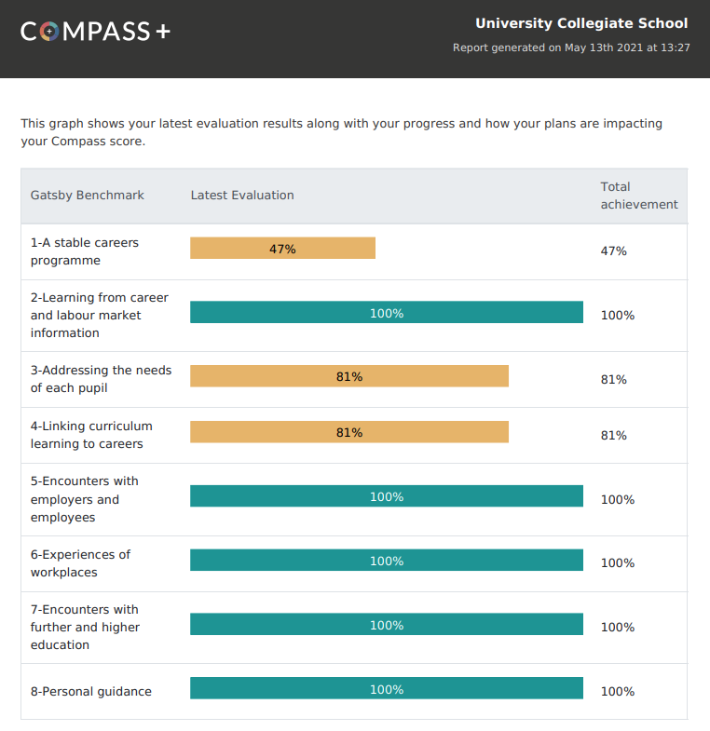

Benchmark | % | Areas to be addressed
1
Stable careers programme
2
Learning from career and labour market information
3
Addressing the needs of each pupil
4
Linking curriculum learning to careers
5
Encounters with employers and employees
6
Experience of the workplace
7
Encounters with further and higher education
8
Personal guidance

Appendix 3 – Gatsby Benchmark Progress

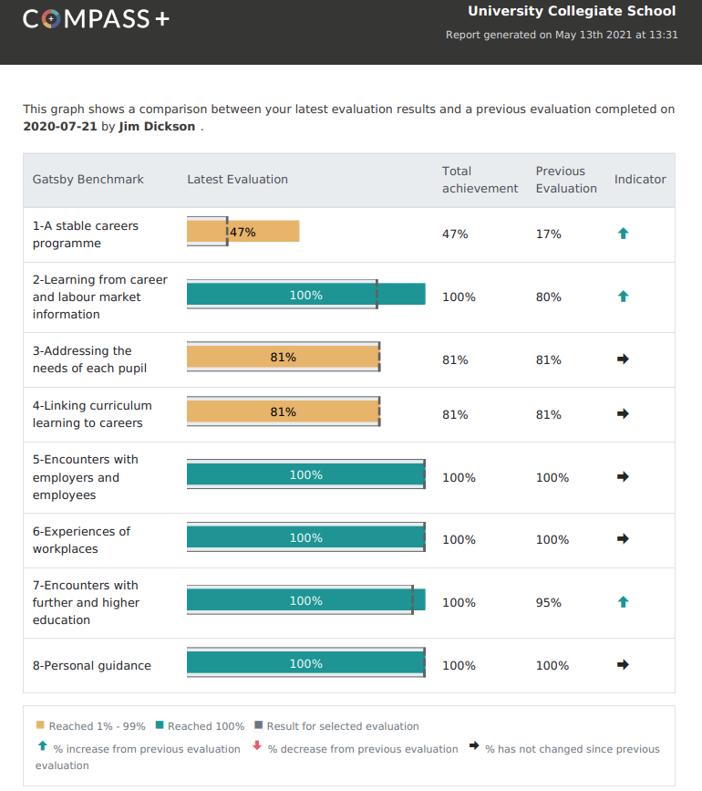

Benchmark | September 2019 | December  2019 | April  2020 | July  2020
1
Stable careers programme
2
Learning from career and labour market information
3
Addressing the needs of each pupil
4
Linking curriculum learning to careers
5
Encounters with employers and employees
6
Experience of the workplace
7
Encounters with further and higher education
8 Personal guidance

